# Link Replacer/DNA Tool

## Introduction

Link Replacer/DNA Tool (from now on simply referred to as “the program”) is an application written in C#. It was designed to bulk manipulate PDFs to relieve the user of performing menial, repetitive tasks and to reduce user error.

## Interface

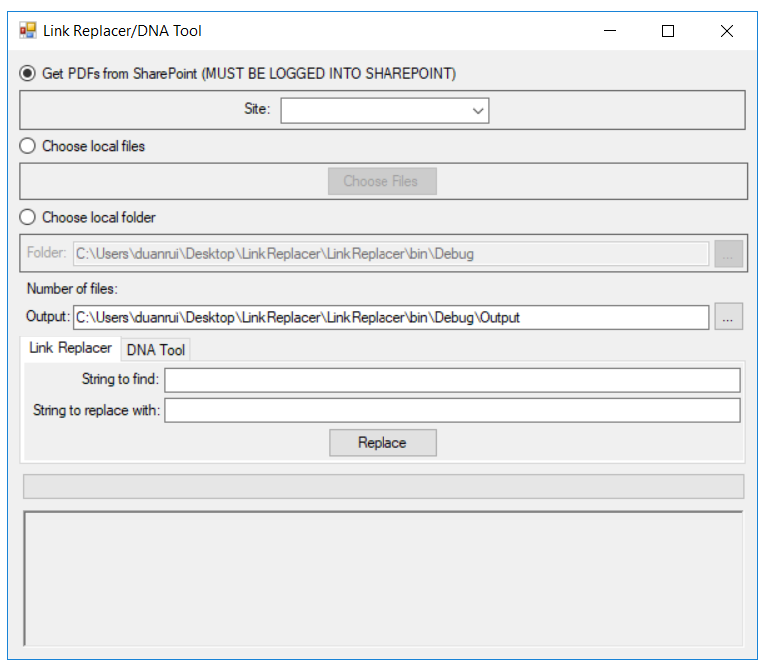

8

7

6

5

4

1

2

3

1. **Get PDFs from SharePoint** (Checked by default): Directly grabs the PDFs from the specific SharePoint site.
2. **Choose local files**: Manually pick file(s) from a file browser dialog, multiple file selection is supported.
3. **Choose local folder**: Grabs all the PDFs in the selected folder. Can either paste the file path directly in the textbox or open the folder browser dialog by pressing the “…” button next to the textbox.
4. **Number of files**: Displays the number of files selected/found in the folder/SharePoint. IMPORTANT – If there is no number after selecting files/folder/SharePoint, something has gone horribly wrong.
5. **Output folder**: Choose where the program places the PDFs/CSV file. Can either paste the file path directly in the textbox or open the folder browser dialog by pressing the “…” button next to the textbox. If the specified path does not exist, the folder will be automatically created.
6. **Link Replacer/DNA Tool tab**: Switch between tools by clicking on the respective tab. More detail below.
7. **Progress bar**: Displays current progress.
8. **Text log**: Displays the current file being read and any warnings/errors that occur.

**IMPORTANT – Search through the text log for “ERROR” messages after the program finishes running to find problematic files.**

## Link Replacer

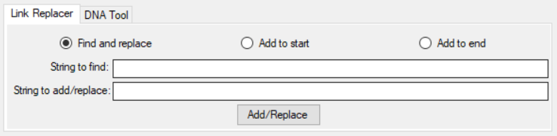

The Link Replacer tool can either act as a find-replace-all tool or add strings to the start or end of hyperlinks that contain the search string.

### Find and replace

If the “Find and replace” option is selected, the tool searches through every hyperlink of the selected PDFs for the matching string, which it then replaces with the specified replacement string. For example:

**String to find**: SITEID

**String to replace with**: RAM

**Old link**: http://operations.connect.na.local/support/Reliability/ReliabilityShared/Pages/AssetRedirect.aspx/?cheese=SITEID=&cheeseNum=B3410=&mobile=0

**New link**: http://operations.connect.na.local/support/Reliability/ReliabilityShared/Pages/AssetRedirect.aspx/?cheese=RAM=&cheeseNum=B3410=&mobile=0

**Note**: This will change all instances of the found string with the replace string. So if there were 2 instances of “SITEID” in the link, both will be replaced with “RAM”.

### Add to start/end

If the “Add to start” or the “Add to end” option is selected, the tool once again searches through every hyperlink of the selected PDFs for a matching string, and then inserts the specified string to add at either the start or end of the original hyperlink. For example:

**String to find**: cheeseNum

**String to add to end**: =&mobile=0

**Old link**:

http://operations.connect.na.local/support/Reliability/ReliabilityShared/Pages/AssetRedirect.aspx/?cheese=RAM=&cheeseNum=B3410

**New link**:

http://operations.connect.na.local/support/Reliability/ReliabilityShared/Pages/AssetRedirect.aspx/?cheese=RAM=&cheeseNum=B3410=&mobile=0

**Note**: To change all the links, leave the “String to find” section blank.

The program will then output a new PDF with the new links at the specified output folder.

## DNA Tool

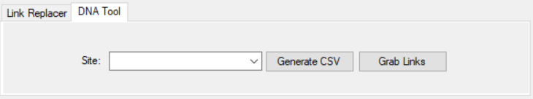

The DNA Tool is a specific tool for generating a csv file to be read by the Asset Finder which contains every asset that shows up in the PDFs. It can also generate a csv file containing every hyperlink that shows up in the PDFs.

### Asset CSV

To generate a csv file to be read by the Asset Finder, select the appropriate site and click “Generate CSV”. The asset csv file should be in the following format:

|  |  |  |  |  |
| --- | --- | --- | --- | --- |
| Asset Number | Asset Name | PDF Link | (Blank) | PDF Name |

However, the tool currently is incapable of getting the asset name. As such, that field is left blank, and the csv generated by the tool is in the form of:

assetNum,,PDFLink,,PDFName

The asset name could be found by later running a VLOOKUP function in Excel using the asset list. An example of a line in the completed csv file is:

S6303,3 Tab Scrap Diverter,http://operations.connect.na.local/support/Reliability/IKOHawkesbury/HawkesburyAssetDocuments/3 Tab Take Away.pdf,,3 Tab Take Away.pdf

**Note**: As the PDF link is site-dependent, it is important to choose the appropriate site before generating the csv. If the files are from SharePoint, the site will be automatically updated.

The tool will then output a csv file titled as the selected site ID at the specified output folder.

The tool works by searching for blue boxes. More specifically, hyperlinks which contain the string “assetnum”, such as:

http://nscandacmaxapp1.na.iko/maximo/webclient/login/login.jsp?mobile=false&event=loadapp&value=createsr&additionalevent=insert&additionaleventvalue=assetnum=S6303

As such, if there is an error in the link itself, the program will be unable to catch it, even if the DNA seems to be perfectly fine. This is why it’s important to search for files the tool had troubles reading.

### Link Grabber

To generate a csv file of every hyperlink that shows up in the PDFs, select the appropriate site and click “Grab Links”. The link csv file should be in the following format:

|  |  |
| --- | --- |
| Hyperlink | PDF Name |

The tool works by searching for annotations in the PDF which are Uniform Resource Identifiers (URIs) and checking if the first 4 characters of the URI matches “http”. As such, if there was an error in entering the link when creating the PDF (such as entering “hhttp” or “vttp”), the tool will not recognize it as a hyperlink and it will be skipped. The tool will output the PDF name and the number of links found in that PDF to the text log.

## Maintenance

As new sites are added or old sites get changes, their information can be updated in the “Sites.csv” file included in the program folder. The file is required for the program to run. The format for a site is:

|  |  |  |
| --- | --- | --- |
| Site Name | Site ID | SharePoint Link |

An example of an entry is:

Calgary,BA,http://operations.connect.na.local/support/Reliability/IKOCalgary/CalgaryAssetDocuments

**Note**: It is important that the SharePoint Link does not contain the final “/”, as it would mess up the program.

The program is available at: [LinkReplacer and DNATool](../../CO-OP%20TOOLS%20AND%20PROGRAMS/LinkReplacer%20And%20DNATool)

Source code and previous versions (might be outdated) available at: <LinkReplacer>, or on GitHub (best bet for the most current version): [GitHub Repository](https://github.com/TanksRUs/LinkReplacer-DNATool)